Soft And Chewy Snickerdoodles
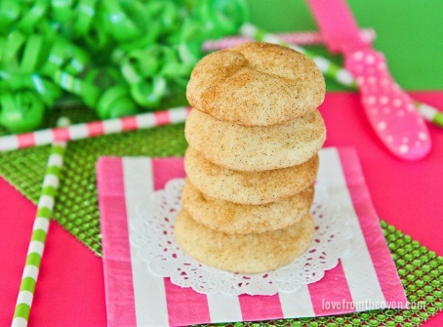
A delicious, soft and chewy snickerdoodle.
Author Christi

Ingredients
- 3 3/4 cups flour
- 1 teaspoon baking soda
- 1/2 teaspoon baking powder
- 1 teaspoon cream of tartar
- 1 cup butter 2 sticks
- 1 3/4 cups granulated sugar
- 2 eggs
- 1/4 cup milk
- 1 teaspoon vanilla

Topping
- 5 tablespoons sugar
- 2 teaspoons cinnamon

Instructions
- For the dough:. In a bowl, sift together the flour, baking soda, baking powder and cream of tartar. Set aside.
- In a separate bowl, cream the butter and sugar until fluffy. Add the eggs, milk and vanilla. Mix well.
- Stir in the dry ingredients. Stir until just combined.
- Cover bowl (or remove dough from bowl and wrap in plastic wrap) and chill for 2+ hours. You can chill for up to 24 hours if you have time.
- When ready to bake, Preheat the oven to 350 degrees. Form the dough into 1 inch balls. Mix cinnamon and sugar in a small bowl and roll each ball of dough through the cinnamon and sugar mixture to coat well.
- Place on a greased baking sheet or a cookie sheet covered with wax paper or silicone baking mat.
- Bake 8-9 minutes. Do not overbake. Allow to cool on baking sheet for at least ten minutes before transferring to a wire cooling rack.

